**DATA DIARY (MAPPING DATA) | QUEENS NAME EXPLORER: LATINO REPRESENTATION**

Dec. 19, 2022

**DATA SOURCES**

* Queens Memory Project
  + Queens Name Explorer Data (excel document shared by organisation, not publicly accessible).
  + Date pulled: Nov. 2022. Provided directly by Natalie Milbrodt, Director of Queens Memory Project and the Queens Name Explorer project
* NYC Planning Demographic Data
  + 2020 Census data - <https://popfactfinder.planning.nyc.gov/>
  + Date pulled: rechecked data on Dec 19. 2022

**LOCATION**

Documents/JSchool/Data/Assignment 3 | Mapping Data

**SCOPE**

Where in Queens can you find streets with Latino honorary names?

Following the Queens Name Explorer project, this part of the story explores where in Queens are the Latino heritage street names and if this matches with demographic data of the area.

**QUESTIONS / DATA I’M LOOKING FOR**

* Main: Low amount of latino names in street / monument honorary naming compared to Hispanic demographic percentages in the Queens area.
* Data I’m showing:
  + Percentage of Hispanic population in the different Queen’s neighborhoods.
  + Honorary naming sites after Latinx people in each neighborhood.

**ANALYSIS**

1. Original data sheet emailed from Queens Memory Project director.
2. Cleaned version from previous project:
   1. Duplications.
   2. Deleted columns I won’t be needing for this specific project / scope.
   3. Added a manual count of latinx honorary names, this wasn’t presented in the data accurately.
3. Created pivot sheet with relevant data for the project to copy on Datawrapper (neighbourhoods + percentage of hispanic population + number of latinx honorary names)
4. Search for demographic data manually on NYC Department of City Planning: Hispanic population in each neighborhood in Queens.
5. Cleaned neighborhoods with no data available.
6. Added demographic data to pivot table.
7. Added number of latinx honorary names manually.
8. Added data on Datawrapper
   1. Issue: no specific map for Queens, choose the one with all NYC NTA’s and then hided regions without data.
   2. Fixed errors on data:

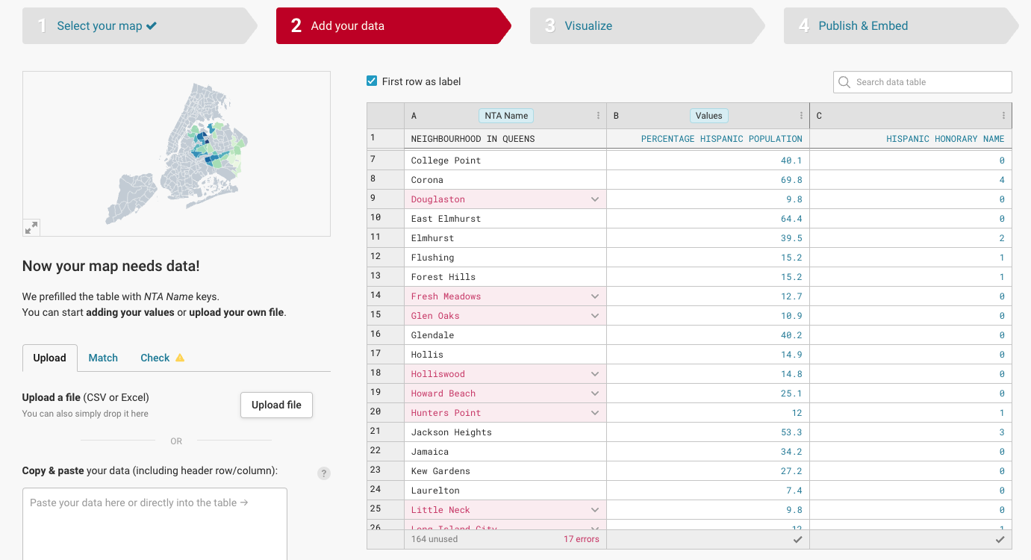

* 1. Long Island City is considered Hunters Point / Sunnyside. Had to sum up the honorary name from LIC to that row.